[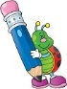](http://www.google.co.uk/url?sa=i&rct=j&q=clipart+writing&source=images&cd=&cad=rja&uact=8&ved=0CAcQjRw&url=http://www.cliparthut.com/writing-folder-clipart.html&ei=dPd2VdDGHILj7Qabg4C4CQ&psig=AFQjCNH0fs5RgKxxjjYWx7Q7pSDbGug4cA&ust=1433946350728263)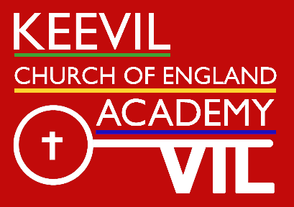**Learning in the**

**English**

Our focus text for this term is The Firework Makers Daughter

This text will be used to develop both reading and writing skills including reading comprehension and creative narrative writing. There will also be the opportunity for nonfiction writing during our study of The Netherlands in geography and during science . We will continue with the program of spelling and will include learning key words. Punctuation and grammar will explore punctuation of speech, conjunctions, and clauses

**term ahead**

**Class: Summer Term:** 4

**Maths**

We will be doing a daily program of times tables. The children will continue developing skills in and they will be exploring fractions and decimals as well as area and perimeter

**PSHE**.

The focus this term is mental health and well being

**PE**

This term the children will be going swimming and doing PE with PH

Sports coaches.

**Geography**

This term the children will be comparing and contrasting the Netherlands and GB. We will be focusing on the physical and human landscape and identifying similarities and differences using contour maps. 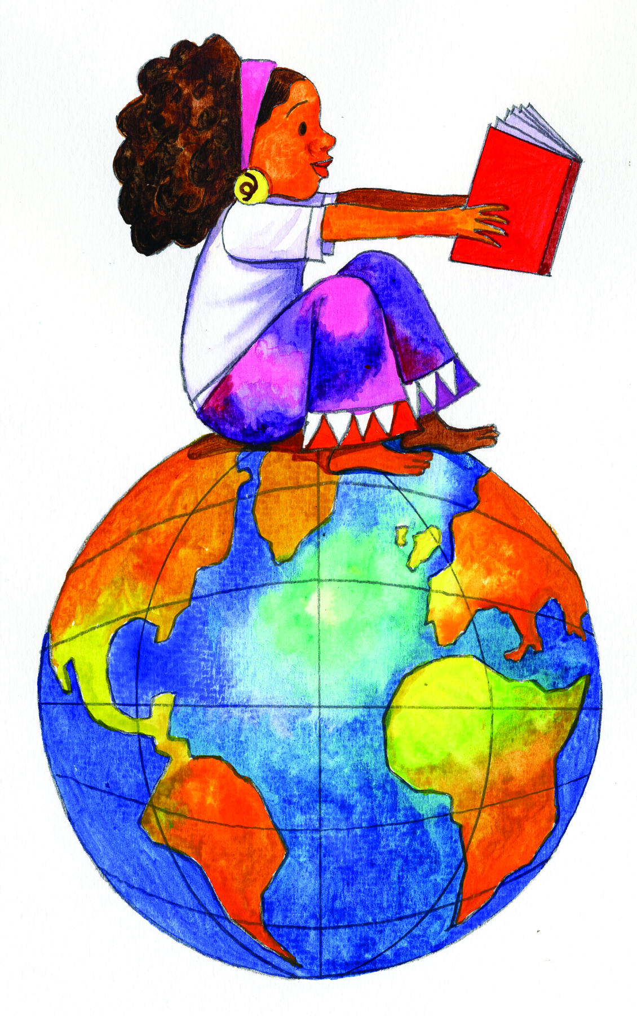

**Science**

We will continue looking at Rocks and Soil then introduce the concept of 'Evolution' and consider the question, What can we learn from fossils?

**RE – Easter**

**Key Question: Is forgiveness always possible?**

**We will consider how the life, death and resurrection of Jesus teaches Christians about forgiveness.**

[](http://www.google.co.uk/url?sa=i&rct=j&q=clipart+religion&source=images&cd=&cad=rja&uact=8&ved=0CAcQjRw&url=http://www.canstockphoto.com/religion-icons-5285101.html&ei=wPd2VeivINDT7AaRiYKQBQ&psig=AFQjCNGvETEcdgp3JNG30BR3eRGGsnGDJw&ust=1433946411911815)

**Computing**

We will be using technology to develop the understanding of AI through use of a range of packages to create images and to write an information leaflet

[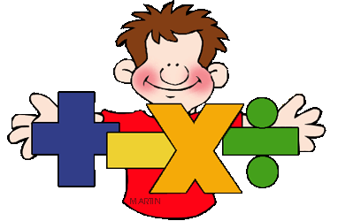](http://www.google.co.uk/url?sa=i&rct=j&q=clipart+maths&source=images&cd=&cad=rja&uact=8&ved=0CAcQjRw&url=http://math.phillipmartin.info/&ei=4_Z2VaiaFciN7AaY9IGwBg&psig=AFQjCNGo5VxK1fCJXBQEo_6NjKx0w56UjQ&ust=1433946187819279)

[](http://www.google.co.uk/url?sa=i&rct=j&q=clipart+computer&source=images&cd=&cad=rja&uact=8&ved=0CAcQjRw&url=http://www.clipartpanda.com/categories/kids-art-class-clip-art&ei=Bvh2Vau4FqTg7QaTgoHQBw&psig=AFQjCNGMIdQ6tV01DJDDgd3KLhh8fcT_JA&ust=1433946483855768)

**Art/DT**

DT will involve an element of cookery and food preparation as well as art reflecting aspects and image from China in relation to the text we are covering

[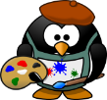](http://www.google.co.uk/url?sa=i&rct=j&q=clipart+art&source=images&cd=&cad=rja&uact=8&ved=0CAcQjRw&url=http://www.clipartpanda.com/categories/artist-clip-art&ei=iPh2Vc-YDMmw7Aa60IPoAg&psig=AFQjCNGPQje2q8Wyzpgs_gyMad_4DvjFHQ&ust=1433946622019842)

**Music** This term Summer class will be continuing to practice the recorder and learn a range of European songs. The children will have several opportunities to perform and show their progress.

[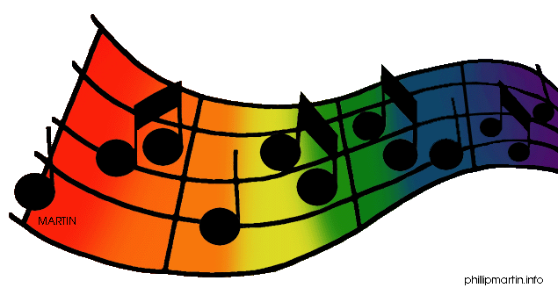](http://www.google.co.uk/url?sa=i&rct=j&q=clipart+music&source=images&cd=&cad=rja&uact=8&ved=0CAcQjRw&url=http://www.clipartpanda.com/categories/clipart-music-notes&ei=0_l2VajADoH67AaDooPYAg&psig=AFQjCNETyjPoJdd0IxJKODwQwHCy81I9rw&ust=1433946955029635)[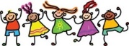](http://www.google.co.uk/url?sa=i&rct=j&q=clipart+friends&source=images&cd=&cad=rja&uact=8&ved=0CAcQjRw&url=http://cliparts.co/clip-art-of-friends&ei=EPp2VbbRMOGs7Ab00oOYBg&psig=AFQjCNEs9KYihyqCQapdwBhANqtbU0KZvQ&ust=1433947009480034)

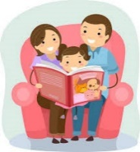

**Learning at home to support work in school**

See the website for additional information for reading, spelling and topic information

<https://www.timestables.co.uk/>

This site has a variety of maths activities:

<https://www.topmarks.co.uk/maths-games/7-11-years/times-tables>

It is important that the children secure their understanding of word classes: nouns, verbs, adverbs, prepositions etc. There are many website to support this, here are just 2:

<http://www.crickweb.co.uk/Key-Stage-2.html>

BBC bitesize offers support for a range of subjects

<https://www.bbc.co.uk/bitesize/levels/zbr9wmn>