**Learning in the**

**English**

This term we will be reading the book Cosmic and using this text to influence some of writing. We will be continuing to look at sentence structure through Spelling Punctuation And Grammar (SPAG) lessons this term, continuing to work on our understanding and application of word classes and using clauses and phrases effectively in our writing.

**term ahead**

**Class: Autumn Term: 2**

[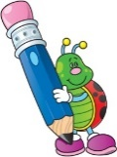](http://www.google.co.uk/url?sa=i&rct=j&q=clipart+writing&source=images&cd=&cad=rja&uact=8&ved=0CAcQjRw&url=http://www.cliparthut.com/writing-folder-clipart.html&ei=dPd2VdDGHILj7Qabg4C4CQ&psig=AFQjCNH0fs5RgKxxjjYWx7Q7pSDbGug4cA&ust=1433946350728263)

**Maths**

In Maths this term we will be continuing to work on the four operations; focusing on multiplication and division. The children will also be working on using statistics; interpreting and constructing pie charts and line graphs and using these to help them solve problems. Finally, using statistics to interpret data – using the mean to find averages.

**RE**

This term the children will be answering the key question: Was Jesus the messiah? The children will be showing their understanding that most Christians believe Jesus is God incarnate and they believe that his birth, life, death and resurrection were part of a longer plan by God to restore the relationship between humans and God. Pupils understand that Christians believe that Jesus fulfilled these expectations, and that he is the Messiah. (Jewish people do not think Jesus is the Messiah.)

[](http://www.google.co.uk/url?sa=i&rct=j&q=clipart+religion&source=images&cd=&cad=rja&uact=8&ved=0CAcQjRw&url=http://www.canstockphoto.com/religion-icons-5285101.html&ei=wPd2VeivINDT7AaRiYKQBQ&psig=AFQjCNGvETEcdgp3JNG30BR3eRGGsnGDJw&ust=1433946411911815)

[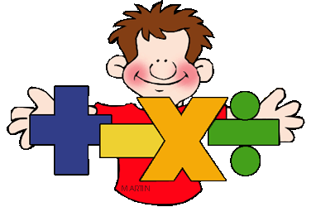](http://www.google.co.uk/url?sa=i&rct=j&q=clipart+maths&source=images&cd=&cad=rja&uact=8&ved=0CAcQjRw&url=http://math.phillipmartin.info/&ei=4_Z2VaiaFciN7AaY9IGwBg&psig=AFQjCNGo5VxK1fCJXBQEo_6NjKx0w56UjQ&ust=1433946187819279)

[](http://www.google.co.uk/url?sa=i&rct=j&q=clipart+computer&source=images&cd=&cad=rja&uact=8&ved=0CAcQjRw&url=http://www.clipartpanda.com/categories/kids-art-class-clip-art&ei=Bvh2Vau4FqTg7QaTgoHQBw&psig=AFQjCNGMIdQ6tV01DJDDgd3KLhh8fcT_JA&ust=1433946483855768)

**Science**

Our science lessons will continue to be based on space – furthering our understanding on the movement of the earth and other planets, how the movement of the Moon is relative to Earth and how Earth’s rotation causes day and night.

**Computing**

This term we will be focusing on E-Safety and our general ICT skills. Demonstrating how to use technology safely and responsibly as well as learning how to use a range of programs effectively.

[](http://www.google.co.uk/url?sa=i&rct=j&q=clipart+science&source=images&cd=&cad=rja&uact=8&ved=0CAcQjRw&url=http://manshamahtani.com/science-fair-clip-art&ei=TPh2VaP3AoSU7AbDsoCICQ&psig=AFQjCNHoHI3d_L_KUxYR_usObtwTDUPUhQ&ust=1433946549049225)

**PE**

This term, the children will be doing Netball in their PE lessons. The children will also be continuing their swimming lessons on a Friday and the weekly ‘dash’ on a Monday.

**History**

In History, the children will be continuing their learning on WW2 and looking at the Key Question: **What was it like to be a child during World War 2?** As part of this topic, the children will be learning about the history and key impacts of WW2 – looking at areas such as evacuees, air raids, how the war began and ended and key figures

[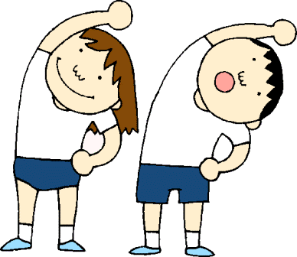](http://www.google.co.uk/url?sa=i&rct=j&q=clipart+pe&source=images&cd=&cad=rja&uact=8&ved=0CAcQjRw&url=http://www.clipartpanda.com/categories/pe-class-clipart&ei=i_l2VdWCNcLB7AbC9YH4CQ&psig=AFQjCNHunG1V_E8HkEKpZlyb39Vtsy2gCA&ust=1433946879166045)

[](http://www.google.co.uk/url?sa=i&rct=j&q=clipart+geography&source=images&cd=&cad=rja&uact=8&ved=0CAcQjRw&url=http://www.clipartpanda.com/categories/geography-clipart-black-and-white&ei=G_l2Vbr0KILm7ga9g4G4BA&psig=AFQjCNGWbF-50cfXyU3PVpIvmPLoTqpYJA&ust=1433946761437782)

**PSHE**

This term the theme of our PSHE day will be on ‘safe relationships’. This will include looking at and discussing privacy and personal boundaries; what is appropriate in friendships and wider relationships (including online); how to recognise pressure from others to do something unsafe or that makes them feel uncomfortable and strategies for managing this.

**Music**

Pupils will explore Holst's 'The Planets' focusing on ostinatos, dynamics, mood, tempo and instrumentation. Pupils will also explore Strauss's 'Also Sprach'. Finally pupils will create a musical soundscape to describe a journey into space.

[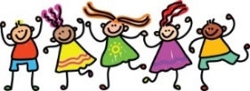](http://www.google.co.uk/url?sa=i&rct=j&q=clipart+friends&source=images&cd=&cad=rja&uact=8&ved=0CAcQjRw&url=http://cliparts.co/clip-art-of-friends&ei=EPp2VbbRMOGs7Ab00oOYBg&psig=AFQjCNEs9KYihyqCQapdwBhANqtbU0KZvQ&ust=1433947009480034)[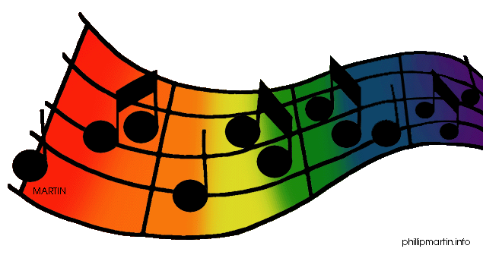](http://www.google.co.uk/url?sa=i&rct=j&q=clipart+music&source=images&cd=&cad=rja&uact=8&ved=0CAcQjRw&url=http://www.clipartpanda.com/categories/clipart-music-notes&ei=0_l2VajADoH67AaDooPYAg&psig=AFQjCNETyjPoJdd0IxJKODwQwHCy81I9rw&ust=1433946955029635)

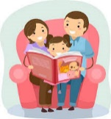

**Learning at home to support work in school**

Primary Games Arena

<http://primarygamesarena.com/Years/Year-6>

Top Marks (Maths)

<https://www.topmarks.co.uk/maths-games/7-11-years/mental-maths>

NRICH (Maths)

<https://nrich.maths.org/9413>

TT Rockstars

<https://ttrockstars.com/>

**Reading** – I want the children to be reading as much as possible, this will have a positive impact on the children’s writing, as well as reading and comprehension. Ask your children about the book/chapter they have read (checking they are understanding the story) as well as asking them about the vocabulary in the book – do you know what this word means or could you think of another (better) word for that?

*Try and use a variety of different texts when reading – Biographies, Fiction books, fact/information books.*

**Maths**

Keep working on four operations/ place value skills.

We have been working on long multiplication over the past few weeks with the year 6 children multiplying 4/5 numbers by 2 digit numbers as well decimal numbers and the year 5 children multiplying 3/4 digit numbers by 1 or 2 digits.

Multiplication/division – rapid recall – quick fire questions – can your child answer multiplication questions without using their fingers?

**Writing**

Keep a diary, write short stories – can you write a story and keep in to 100 words (much harder than it sounds) Find a picture and ask them to write anything they like – newspaper article, diary entry etc. Let them be creative and use their imagination!

Y5 and Y6 will be getting a selection of Maths and English revision bundles. These can be completed as an when you wish and have all of the answers with them.