**Keevil CofE Academy Behaviour Curriculum**

We view our curriculum as everything we offer and provide within school for our children, covering the academic and beyond.

Our curriculum is rooted in our vision and ethos which arise from the parable of the Good Samaritan, and Jesus' teaching to "Always treat others as you would like to be treated." (Matthew 7:12).  In the story of the Good Samaritan we come to understand how someone reached out and gave all he could to someone to whom he could have turned his back.  This underpins everything we do and are in the school.

From this foundation come our values, or 'Keevil Characteristics' of Resilience, Diligence, Problem-Solving, Communication, Learning and Team-Work. Whatever activity or lesson the children are engaged in, we are endeavouring to develop these characteristics within them. Through doing this we are supporting our children to grow into adults who are polite, respectful, grateful and who put others before themselves.

**Teaching the Behaviour Curriculum**

We teach our Behaviour Curriculum explicitly as we do all National Curriculum subjects. This begins at the start of the school year in September, and is re-visited regularly throughout the year, particularly at the start of each new term. This ensures that children learn the content of the curriculum so that they can recall the information and more importantly act upon it.

Teachers also demonstrate these behaviours and ensure that pupils have many opportunities to practise these. They ensure that high standards of behaviour are continuously maintained. By doing this we support each other to create a culture where pupils feel safe and are able to learn in an optimised environment and where teachers are free to teach unimpeded.

|  |  |  |  |  |  |  |
| --- | --- | --- | --- | --- | --- | --- |
|  | **Autumn 1** | **Autumn 2** | **Spring 1** | **Spring 2** | **Summer 1** | **Summer 2** |
| **All Year**  **Groups From**  **YR to Y6** | Explicit teaching of the full  Keevil Behaviour curriculum content | Ongoing revision of content – revisit any specific areas for improvement. | Longer recap of  Keevil Behaviour curriculum | Ongoing revision of content – revisit any specific areas for improvement. | Longer recap of  Keevil Behaviour curriculum | Ongoing revision of content – revisit any specific areas for improvement. |

**Curriculum Content**

Our curriculum is based around our school values – the Keevil Characteristics. By living these values we will demonstrate the following behaviours in school:

|  |  |  |  |  |  |
| --- | --- | --- | --- | --- | --- |
| **Learning** | **Resilience** | **Communication** | **Team Work** | **Diligence** | **Problem-Solving** |
| * Sitting still * Listening carefully in lessons * Giving 100% of attention | * Working hard on all tasks given * Having another go when things go wrong | * Say please and thank you * Say good morning/afternoon to others * Use words to express feelings * Explain thoughts and opinions clearly | * Talk kindly to others * Hold doors open for adults * Accepting responsibility if you make a mistake and saying sorry * Listen to others and consider their point of view | * Showing pride by always doing your best * Completing homework on time * Remembering to bring equipment to school * Being in the right place at the right time | * Work independently to find an answer before turning to an adult * Try different ways to achieve a solution without giving up * Find compromises when solving issues with others |

**Adaptations**

While this curriculum is intended for all pupils it will be applied differently in different year groups depending on pupils’ ages and may be applied differently depending on individual pupils’ SEND needs. Sensitivity must be applied at all times when teaching the behaviour curriculum.

**Whole School Behaviour Expectations and Routines**

In order to follow and successfully implement our behaviour expectations at Keevil School, staff use explicit teaching of how we want our children to behave.

Children are taught to ‘CARE’ for each other, in order to reinforce the school behaviour expectations.

To CARE for someone means:

C onsideration for others – use positive language and kind words.

A lways treat everyone the way you would like to be treated.

R espect others and listen to their opinions.

E ncourage others and off support.

***Moving Around School***

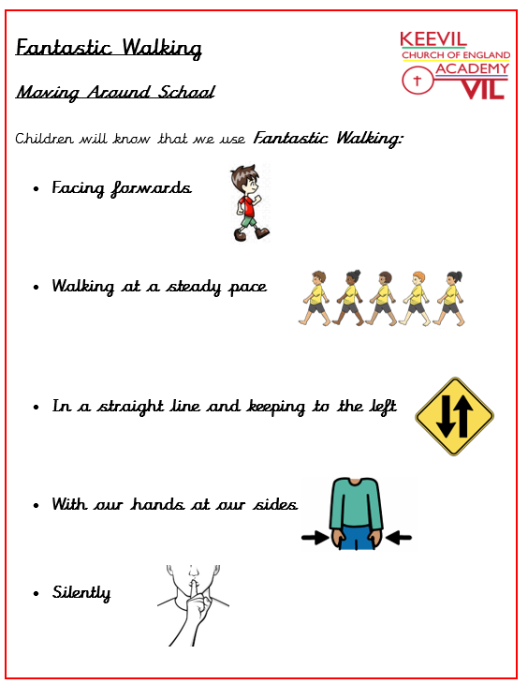**Fantastic Walking**

* Facing Forwards
* Walking at a steady pace
* In a straight line and keeping to the left
* With our hands at our sides
* Silently

Know that when we move around school we walk on the left of the corridor.

Know that we use Fantastic Walking to keep everyone safe in school and to make sure the

learning of other children is not disrupted as people move around school.

***Worship***

* Jumpers on
* Come in to worship using **fantastic walking** in line order
* Sit in lines of 4 (Autumn, Spring and Winter classes) or 3 (Summer class), with Autumn and Spring on the righthand side and Summer and Winter on the lefthand side of the hall
* Sit where directed by either a prefect or an adult
* Sit in silence
* Stand up to leave when directed by either a prefect or an adult
* Leave in silence using **fantastic walking**

***Dining Hall***

* Enter the hall using **fantastic walking** in line order
* Collect lunch equipment
* Sit in silence
* Children with packed lunch can eat straight away
* Children having hot dinners sit silently and wait to be called by staff member
* Children eat silently until an adult directs them to quiet table talk
* No one should leave their seat unless there are otherwise instructed by an adult
* Tables will be instructed to scrape plates one table at a time
* Children will leave the hall at 12.25pm (1st Sitting) or 12.55pm (2nd Sitting)
* All children to be sent to the playground to line up with their classes using **fantastic walking**

***End of Break Time***

* Bell rings
* Children stand still and silent
* Adult instruction to put equipment away and line up
* Children to use fantastic walking to their lines
* Children will line up in their lining up orders
* Prefects to monitor lines
* Prefects are able to give one House Point to children – Prefect must take children to their class and inform member of staff
* Two Year 6 children will tidy trolley at the end of break and put trolley away at the end of lunch.

***End of Day***

* Jumpers on
* **Fantastic walking** outside into lines
* Staff member will release children to trusted adult
* Children will stay in their line(s) until they are released by staff member. If a child is at the back of the line and can see their trusted adult, they can put their hand in the air until staff member sees and releases them.

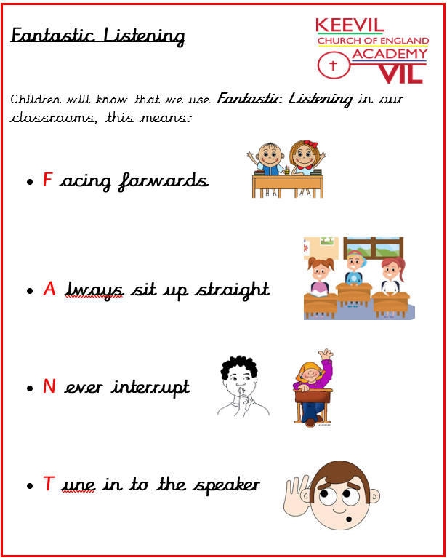

**Expectations for the classroom**

**Fantastic Listening is:**

Facing forwards

Always sit up straight

Never interrupt

Tune in to the speaker

The children know that this enables them to listen and gives them the best opportunity to learn effectively.

***Manners***

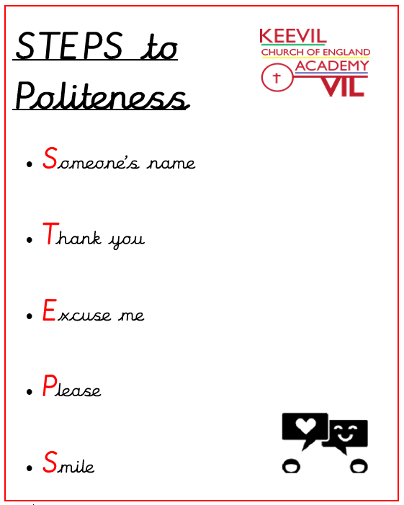**Steps to Politeness**

* **Someone’s name** - pupils know that they must use a person’s name when talking to

members of staff ( e.g. Good morning Mr McCaldon) or their peers.

* **Thank You** - pupils know that they should say ‘thank you’ when they receive something

or someone does something nice for them.

* **Excuse Me**- pupils know that they should say ‘excuse me’ if someone is in their way or if

they need to ask for something (e.g. Excuse me, please could I have…)

* **Please** - pupils know that they should always say ‘please’ when they are asking for

something.

* **Smile** - pupils know that they should be positive and upbeat when talking to adults and

each other.

Smile refers to being upbeat and positive in our interactions and conversations with other people.

We also want to support our children in the way we interact and communicate. We can do this by modelling and encouraging them to use polite questions such as: Did you have a nice evening? Have you had a good weekend?

**Classroom Behaviour Expectations and Routines**

Each class establishes their behaviour expectations and routines at the start of each school year, as is appropriate to the age and group of children in the class. These are rooted in the vision and ethos of the whole school, and the Keevil Characteristics.

Classroom expectations are clearly displayed in a manner that is appropriate for the children in the class.

Classroom expectations are explicitly taught and regularly re-visited, to ensure that children know, remember and act on these.